Week 4 Day 2 July 21, 2026

DOM, DOM events and event handler

Exercise
https://codepen.io/chaumdh/pen/vEgazKP
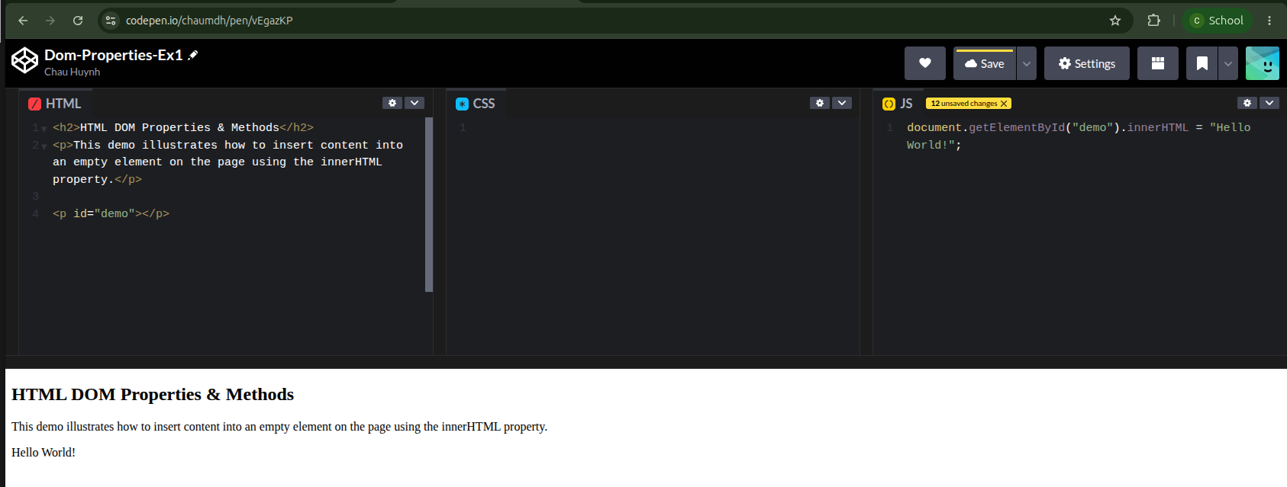

https://codepen.io/chaumdh/pen/XJpBPNz
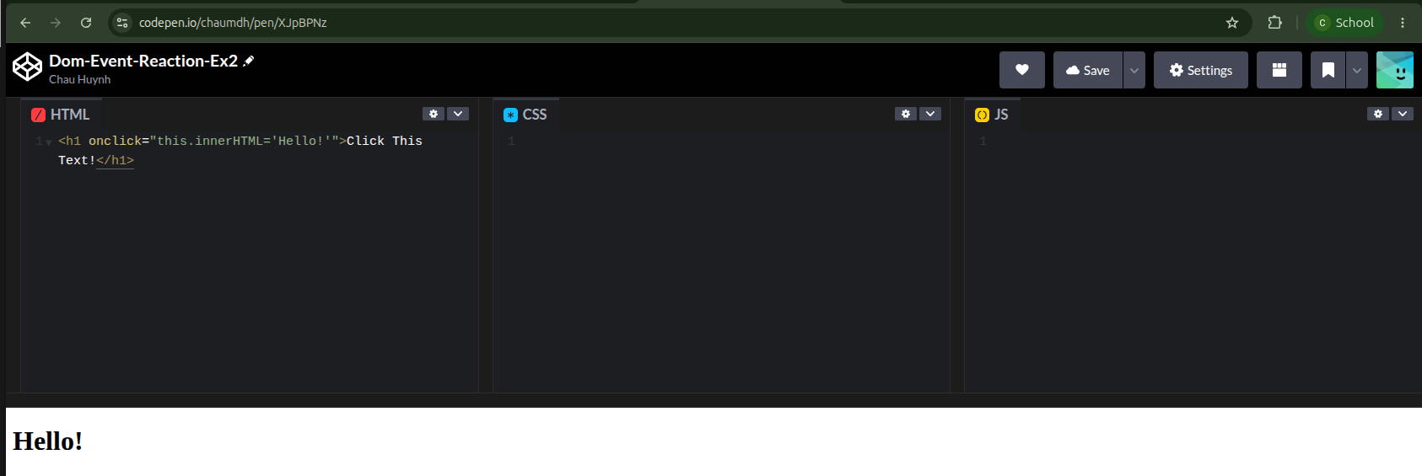

https://codepen.io/chaumdh/pen/WbRKgRw
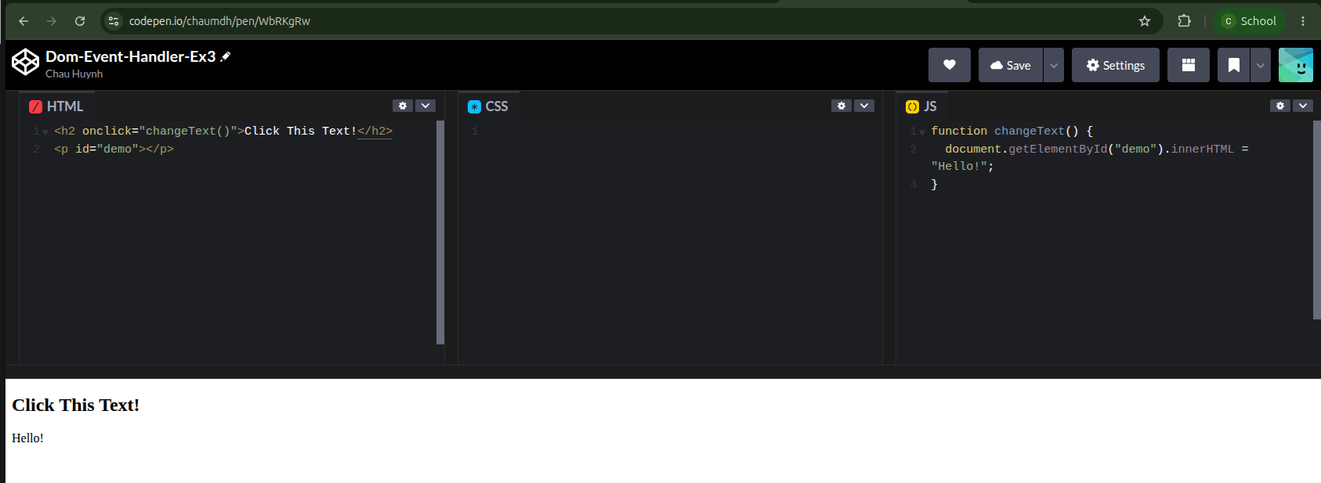

https://codepen.io/chaumdh/pen/myRjGRZ
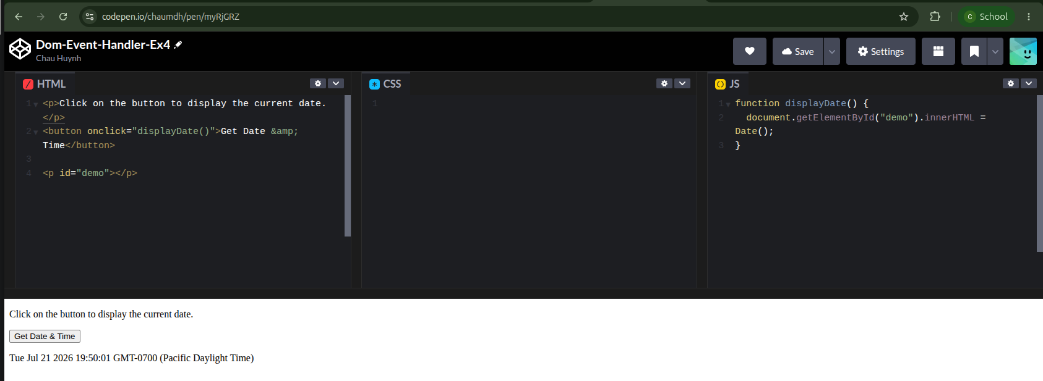

https://codepen.io/chaumdh/pen/NPdBLjN
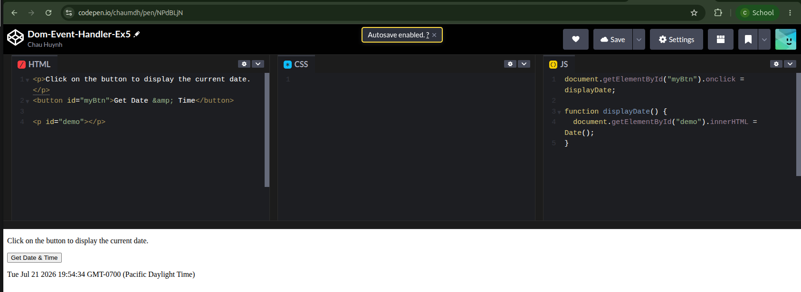

https://codepen.io/chaumdh/pen/BypPOZN
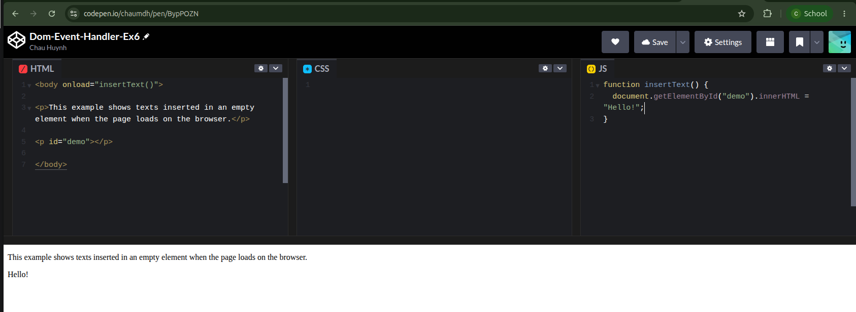

https://codepen.io/chaumdh/pen/qERyMjJ
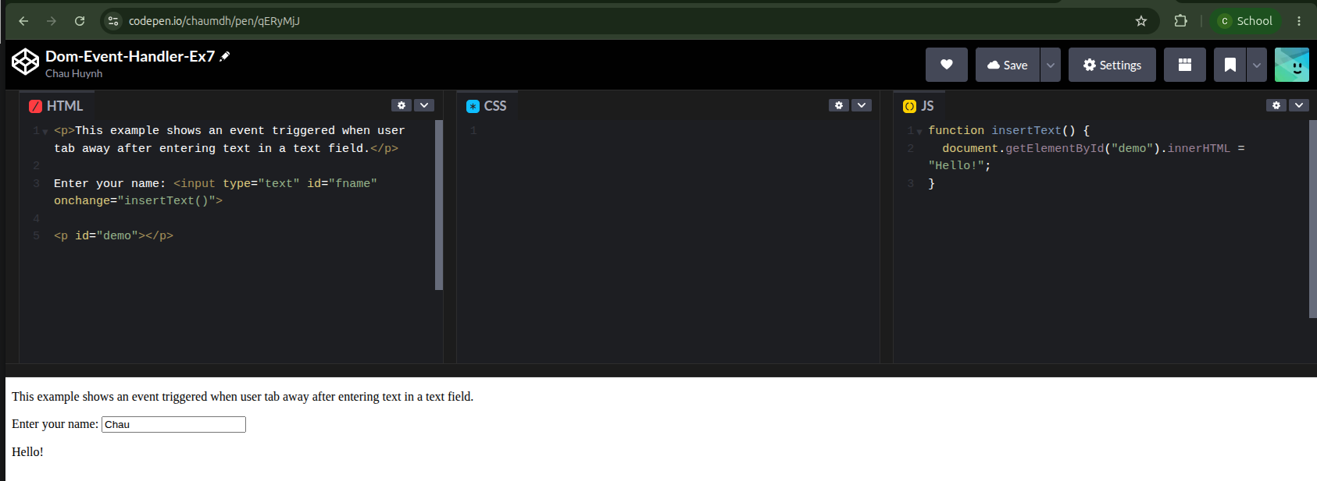

https://codepen.io/chaumdh/pen/myRjGMN
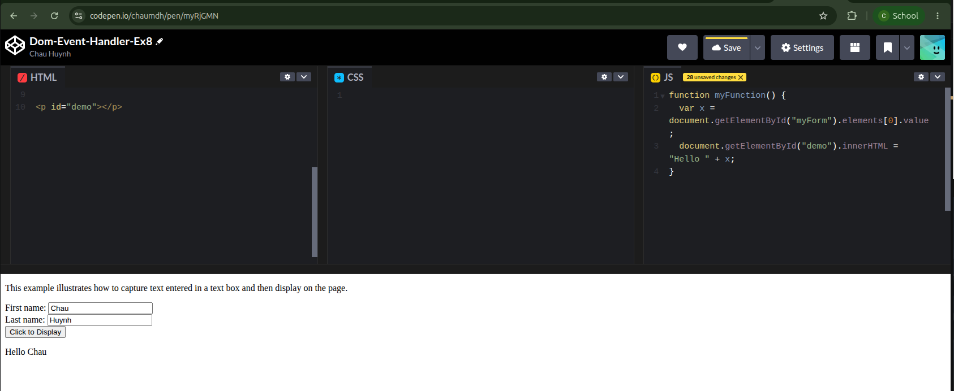

https://codepen.io/chaumdh/pen/VYPBGMR
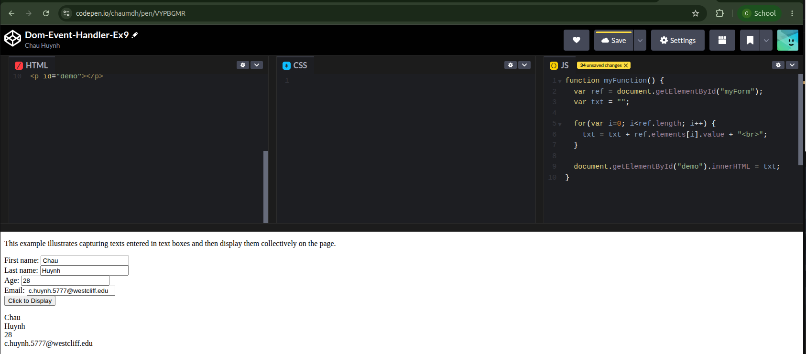

https://codepen.io/chaumdh/pen/ZYLjMva
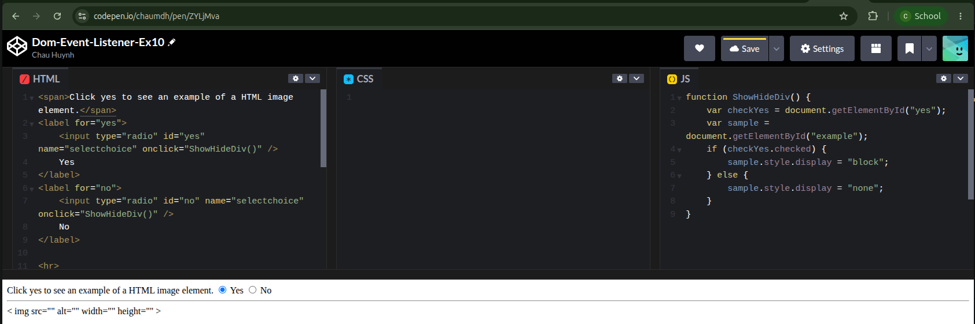

https://codepen.io/chaumdh/pen/gbgjdvb
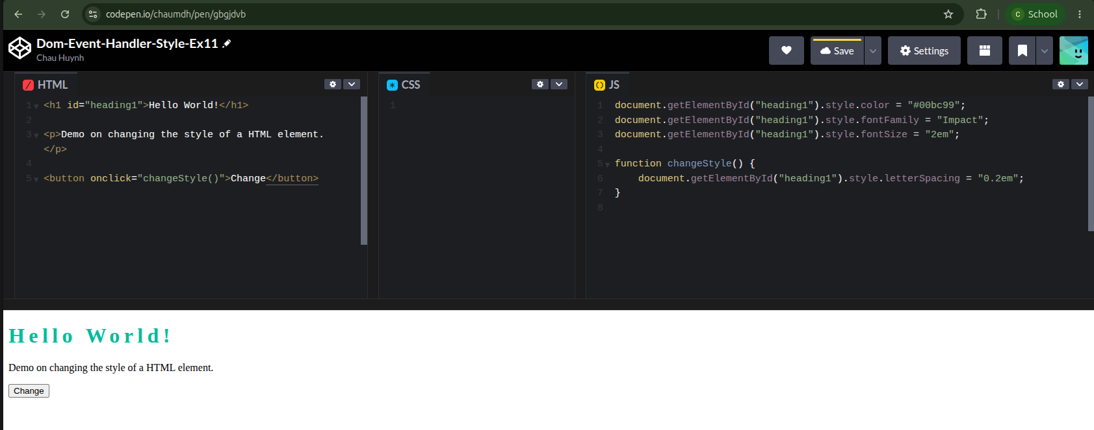
https://codepen.io/chaumdh/pen/wBgxEmG
